Digraphs from set 1
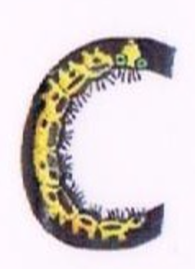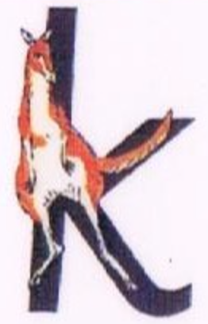 |  | Caterpillar and the kangaroo  “Ck ck ck”  Bouncy sound |  | back  kick  lock  duck
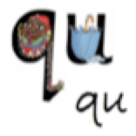 |  | Round her hair up past her earrings and down her hair  “qu qu queen”  Bouncy sound |  | quiz  quit  quiz  quack
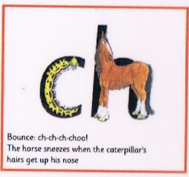 |  | The horses sneezes when the caterpillar’s hair get up his nose  “ch ch ch choo!”  Bouncy sound |  | chin  chop  chat  chick
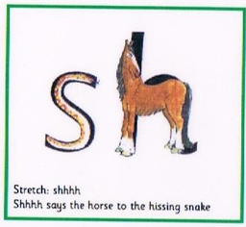 |  | Shhhh says the horse to the hissing snake  “ssssh!”  Stretchy sound |  | ship  shop  dash  dish  wish
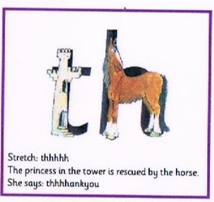 |  | The princess in the tower is rescued by the horse  “thhhhankyou”  Stretchy sound |  | this  that  bath  moth  thin  thick  this
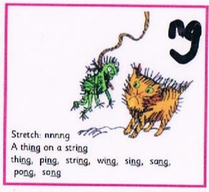 |  | The cat is frightened by …  A thing on a string  “nnnnng”  Stretchy sound |  | thing  ping  string  wing  pong  song  sing  wing  bang
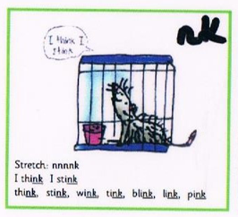 | The rat says to himself…  “I think I stink!”  Stretchy sound |  | think  stink  blink  link  wink  sink  bank  pink
