 | Autumn | Autumn | Spring | Spring | Summer | Summer
Year 1  Pathways to Write Texts | 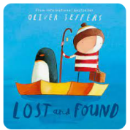  Lost and Found | 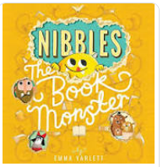  Nibbles | 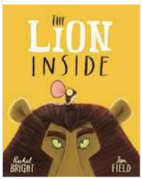  The Lion Inside | 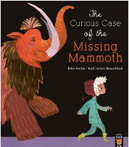  The Curious Case of the Missing Mammoth | 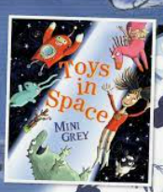  Toys in Space | 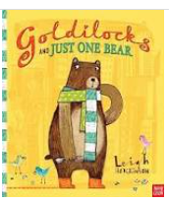  Goldilocks and Just One Bear
Reading | RWInc Phonics  Whole class storytime using Favourite Five Texts | RWInc Phonics  Whole class storytime using Favourite Five Texts | RWInc Phonics  Whole class storytime using Favourite Five Texts | RWInc Phonics  Whole class storytime using Favourite Five Texts | RWInc Phonics  Whole class storytime using Favourite Five Texts | RWInc Phonics  Whole class storytime using Favourite Five Texts
Maths | Place Value  Addition and Subtraction | Addition and Subtraction  Geometry | Place Value  Addition and Subtraction | Place Value  Length and Height  Mass and Volume | Multiplication and Division  Fractions  Geometry | Place Value  Money  Time
 | Town and Country |  | Kings, Queens, and Castles |  | Time Travel
 | History | Geography | History | Geography | History | Geography
Wider Curriculum | How Tattenhall and Chester changed since my grandparents has were little? | Where in the world do I live?  Locality | Where did kings and queens live through time?  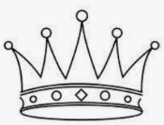 | Comparing where I live to a small area in the UK- Conwy  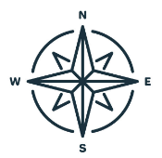 | How has travel changed over time?  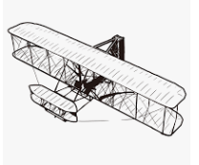 | Traffic and transport  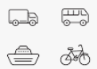
Science Learning | Animals including humans  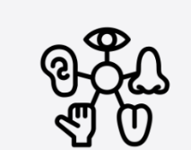  Seasonal change – Autumn to Winter  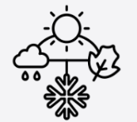 |  | Plants  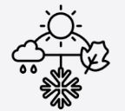  Seasonal change – winter to spring |  | Materials  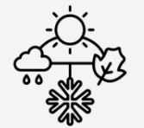  Seasonal change – spring to summer  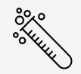

RE | Christianity  What does it mean to belong? | Why is Christmas celebrated by Christians? | 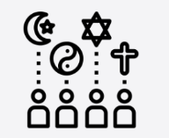World Views  What is Religion? | Islam  How and why are Allah and Muhammad important to muslims? | Christianity  What do we think about how the world was made and how we look after it? | Islam  How do Muslims express new begginings?
No Outsiders | No Outsiders | Elmer  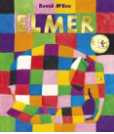 | Ten Little Pirates  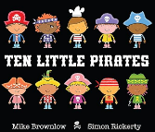 | Max the Champion  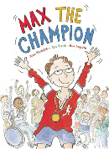 | 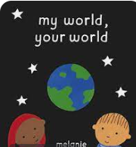  My world, your world, | My grandpa is amazing  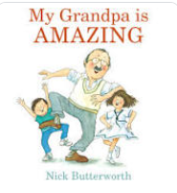
PE | Cross Country & Circuit Training  Multi Skills- netball/ basketball  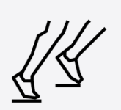 |  | Gymnastics &  Dance  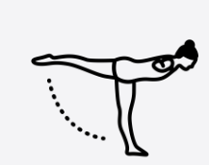 |  | Atheletics & Cricket  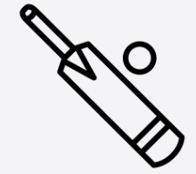
Design & Technology | Sewing- Puppets |  | Strutures- Windmills  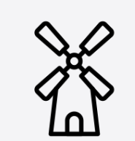 |  | Cooking and Nutrition- Smoothies  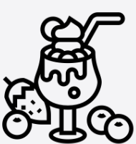
Computing
Art | Drawing: Make your mark  Art project based on topic theme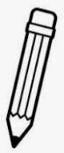 |  | Sculpture and 3D: Paper play  Art project based on topic theme  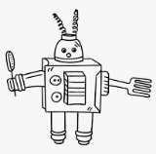 |  | Painting and mixed media: Colour splash  Craft and design: Woven wonders
Music

 | Autumn | Autumn | Spring | Spring | Summer | Summer
Year 2  Pathways to Write Texts | The Lion Inside | 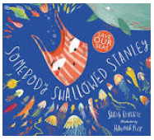  Someone Swallowed Stanley | 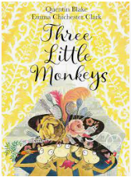  The Three Little Monkeys | 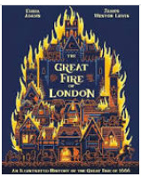  The Great Fire of London | 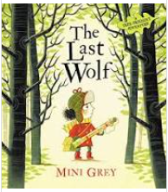  The Last Wolf | 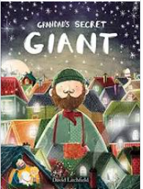  Grandad’s Secret Giant
Steps 2 Read Texts | Fairy Tales and Poetry  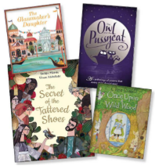 | Rivers and Seas  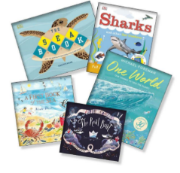 | Stories, Plays and Poetry  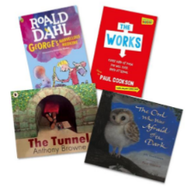 | Events beyond living memory – GfoL  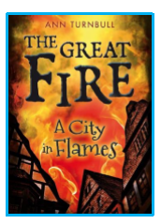 | Traditional Tales and Poetry  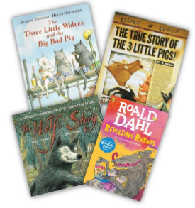 | Living things, habitats and plants
Maths | Place Value  Addition and Subtraction | Addition and Subtraction  Shape | Money  Multiplication and Division | Length and Height  Mass, capacity and temperature | Fractions  Time | Statistics  Position and Direction
 | Explorers |  | London’s Calling! |  | Endangered!
 | History | Geography | History | Geography | History | Geography
Wider Curriculum | Where have humans explored?  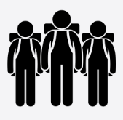 | Continents and Oceans  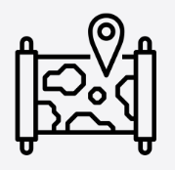 | How did the Great Fire change London?  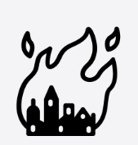 | The UK | Who has made a significant impact on where we live?  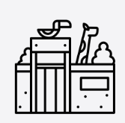 | Comparing Tattenhall to Mugurameno (a village in Zambia)
Science Learning | Animals including humans  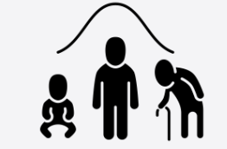  Seasonal change – Autumn to Winter |  | Materials  Seasonal change – winter to spring |  | Plants  Living things and their habitats  Seasonal change – spring to summer  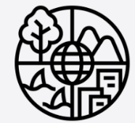

RE | Judaism  What do Jews believe about God? | Judaism  How do Jews show their faith through rituals and practices? | Christianity  Who was Jesus and why is he important to Christians today? | Christianity  Why is the bible important for Christians? | Christianity  Why did Jesus teach people through stories? | World Views  What is humanism?
No Outsiders | 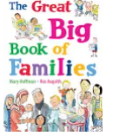  The great big book of families | The First Slodge  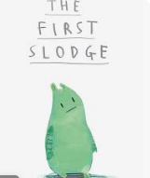 | The Odd Egg  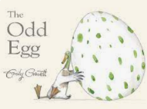 | Just Because,  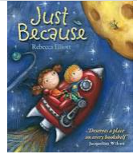 | Blown Away  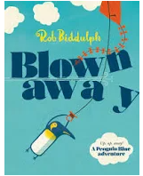
PE | Cross Country & Circuit Training  Multi Skills- netball/ basketball |  | Gymnastics &  Dance |  | Athletics & Cricket
Design & Technology | Mechanisms- A Moving Monster |  | Mechanisms- A Fairground Wheel  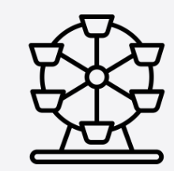 |  | Structures- Baby Bear’s Chair
Computing
Art | Craft and design: Map it out  Art project based on topic theme |  | Sculpture and 3D: Clay houses Art project based on topic theme  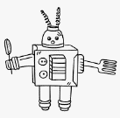 |  | Painting and mixed media: Life in colour and Drawing: Tell a story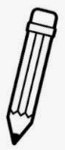
Music

 | Autumn 1 | Autumn 2 |  | Spring 1 | Spring 2 |  | Summer 1 |  | Summer 2
Year 3  Pathways to Write Texts | 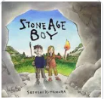  Stone Age Boy | 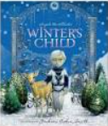  Winter’s Child |  | Seal Surfer | 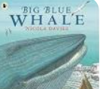  Big Blue Whale |  | 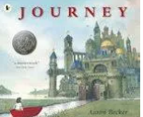  Journey |  | 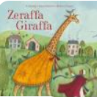  Zeraffa Giraffa
Steps 2 Read Texts | 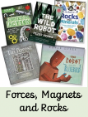 | 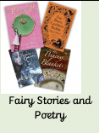 |  | 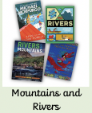 | 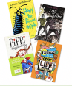 |  | 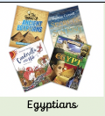 |  | 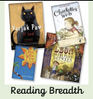
Maths | Place Value  Addition & Subtraction | Multiplication & Division |  | Multiplication & Division  Length & Perimeter | Fractions  Mass & Capacity |  | Fractions  Money  Time |  | Shape  Statistics
 | History | Geography |  | Geography | History |  | History |  | Geography
Wider Curriculum | Through the ages- Stone Age to the Iron Age  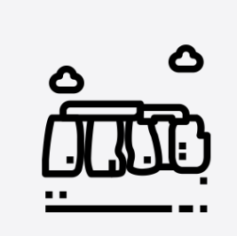 |  | Marvellous Maps- UK and beyond  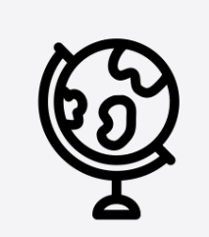 | Let’s flow- Rivers and the Water cycle  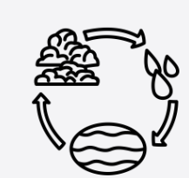 |  | Curious about Canals- local study  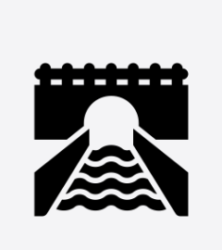 | 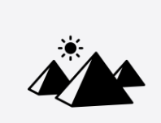  Ancient Civilisations- Life on the Nile: The Egyptians | The land around us…  Are all settlements the same? Comparison with Tattenhall, Chester and New Delhi  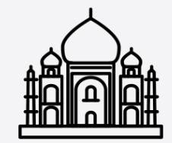
Science Learning | 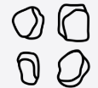  Rocks & Soils |  | Forces & Magnets | Light |  | Plants  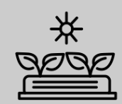 | 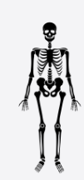  Animals inc humans  Skeletal system, muscles and nutrition
RE | Hinduism  How do Hindus view God and how is Diwali celebrated? |  | Humanism  How do humanists value humanity and celebrate achievements? | Christianity  How do Christians use the bible to help them with their lives? |  | Christianity  How is Jesus portrayed in Art around the world? | Islam  How do Muslims worship? | My life, my religion  What are my views about God and Faith?
No Outsiders | 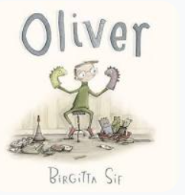  Oliver by Birgitta Sif |  | 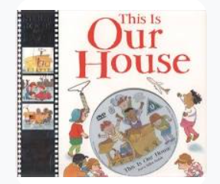  This is our house by Michael Rosen | 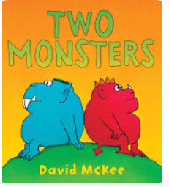  Two Monsters by David Mckee |  | 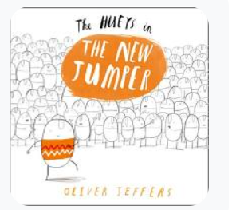  The Hueys in the New Jumper by Oliver Jeffers | 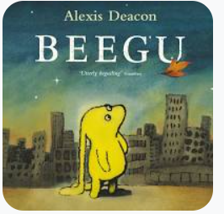  Beegu by Alexis Deacon
PE | Cross- Country  Tag Rugby & Hockey  Basketball, Circuit training & Indoor Athletics |  |  | Badminton & Yoga  Tennis & Gymnastics  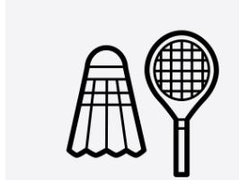  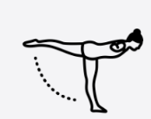 |  |  | Athletics, Orienteering  Cricket & Rounders  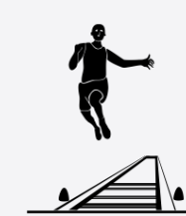
Design & Technology | Digital world  Wearable Technology |  |  | Cooking & Nutrition  Eating seasonally 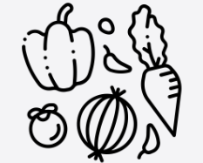 |  |  | Structures- Constructing a castle  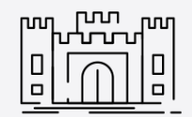
Art | Pre-historic painting  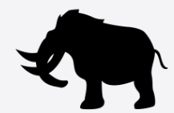 |  | Art project on topic or text. | Sculpture & 3D  Abstract shape and space |  | Art project on topic or text. | Craft & Design  Ancient Egyptian Scrolls  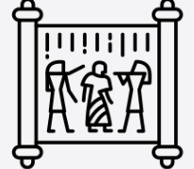 | Art project on topic or text
Music | Ballads  Story behind song |  | Animation compositions- Mountains  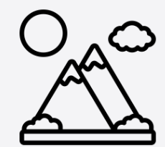 | Pentatonic melodies- Chinese New year  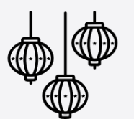 |  | Pitch, tempo & Dynamics  (Rivers)  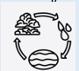 | Jazz  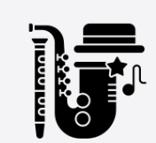 | Instruments & Improvisation  (India)  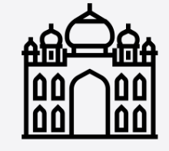
Computing
French

 | Autumn 1 |  | Autumn 2 | Spring 1 |  | Spring 2 | Summer 1 | Summer 2
Year 4  Pathways to Write Texts | 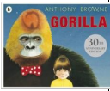  Gorilla | 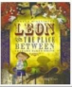  Leon and the place between |  | 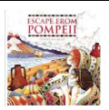  Escape from Pompeii | 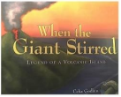  When the Giant Stirred |  | 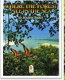  When the Forest Meets the Sea |  | 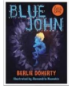  Blue John
Year 4 Steps 2 Read | 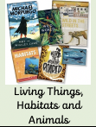 | 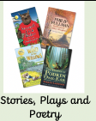 |  | 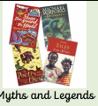 | 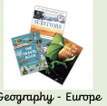 |  | 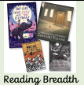 |  | 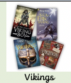
 | History |  | Geography | History |  | Geography | Geography | History
Wider Curriculum | Arrival on the shores of Britain- The Celts and the Romans.  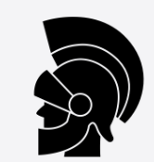 |  | Volcanoes and Earthquakes  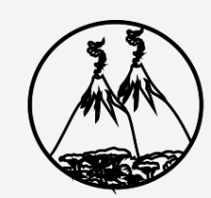 | Anglo-Saxons & Scots  Life after the Romans |  | Mapping food trade around the world. Local versus global. | Why are rainforests important to us?  Compare Delamere Forest and the Amazon. | Anglo-Saxons and Vikings- Vicious or Victorious?  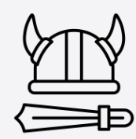
Science Learning | Living things and their habitats  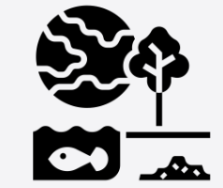 |  | Sound | Electricity |  |  | States of matter | The digestive system  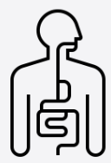
RE | Judaism  How do Jews demonstrate faith through their community? |  | Christianity  Why do Christians think about Incarnation at Christmas? | Christianity  How can I understand different Easter concepts? |  | What is a Hindu worldview & How do Hindus worship? | World Views  What is the Baha’i Faith? | Hinduism  How do Hindu’s worship? Compare with other world views taught so far.

No Outsiders | 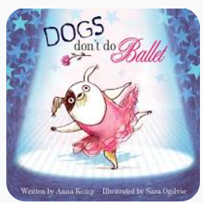  Dog’s don’t do ballet by Anna Kemp | 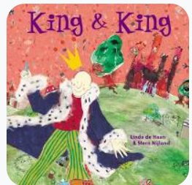  King & King by Linda Dehann | 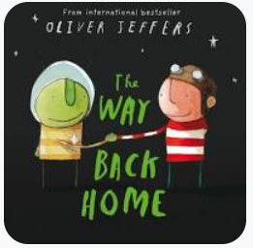  The way back home by Oliver Jeffers | 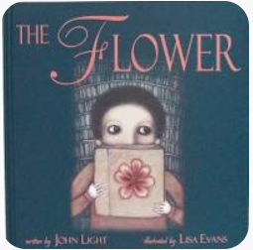  The flower by John Light | 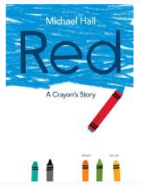  Red: A crayon’s story by Michael Hall
D&T | Structure- Pavillions  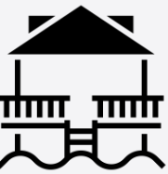 |  | Mechanism- a slingshot car |  | Textiles- Fastenings  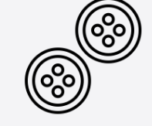
Computing
PE | Cross- Country  Tag Rugby & Hockey  Basketball, Circuit training & Indoor Athletics |  | Badminton & Yoga  Tennis & Gymnastics |  | Athletics, Orienteering  Cricket & Rounders
Art | Painting- Light & Dark  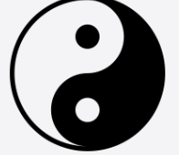 | Art Project based on text or topic | Power Prints  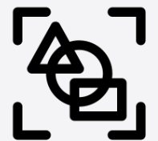 | Art Project based on text or topic | 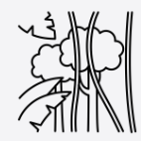 | Art Project based on text or topic
Music | Adapting and transporting motifs- The Romans | Rock & Roll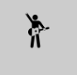 | Samba & Carnival sounds- South America  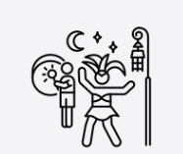 | Haiku, music & performance- The Hanami festival | Body & Tuned Percussion- Rainforests  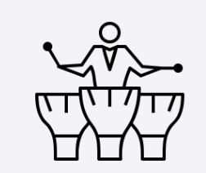 | Develop singing technique- Sing like a Viking
French

 | Autumn 1 | Autumn 2 | Spring 1 | Spring 2 | Summer 1 | Summer 2
Year 5  Pathways to Write texts | 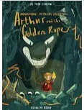  Arthur & the golden rope | 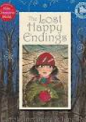  Lost happy endings | 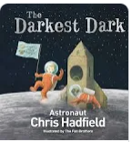  The Darkest Dark | 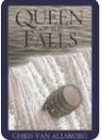  Queen of the Falls | 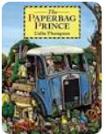  The Paperbag | 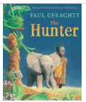  The Hunter
Steps 2 Read | 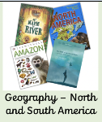 | 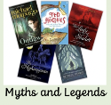 | 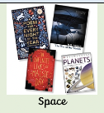 | 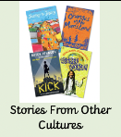 | 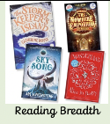 | 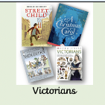
 | Geography | History | History | Geography | Geography | History
Wider Curriculum | Global Deserts- The Mojave Desert  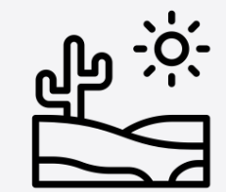 | Ancient Civilisations – The Maya  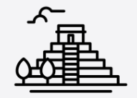 | Ancient Greece- The study of Greek life | The Alps & Tattenhall. What is life like in the Alps? Compare to children’s own locality.  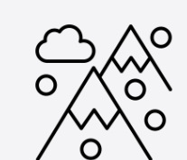 | Energy & Sustainability-Children are our future.  Local fieldwork  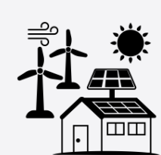 | The Victorians- Childhood in Cheshire  Local study  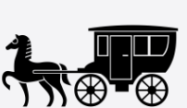
Science Learning | Materials  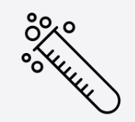 |  | Earth & Space  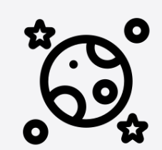 | Forces | Animals inc Humans  Life processes (SRE) 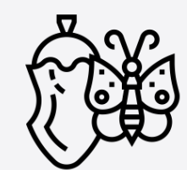 | Living things & habitats
RE | Which concepts do we find hard to understand in Christianity? | What can we learn from religious buildings and music? | Islam  Why are the 5 pillars important to muslims? | Islam  How is the Muslim faith expressed through family life? | 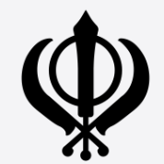  Sikhism  Why is equality & community important to Sikhs? | World views  Angels

No Outsiders | 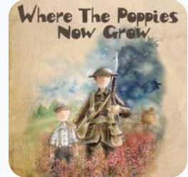  Where the poppies now grow by Hillary Robinson |  | 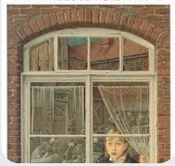  Rose Blanche by Ian Mcewan |  | 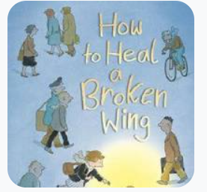  How to heal a broken wing by Bob Graham
Design & Technology | Electrical System- Doodlers  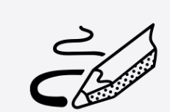 |  | Mechanical systems- A  pop-up book |  | Cooking & Nutrition- what could be healthier?
PE | Cross- Country  Tag Rugby & Hockey  Basketball, Circuit training & Indoor Athletics |  | Badminton & Yoga  Tennis & Gymnastics |  | Athletics, Orienteering  Cricket & Rounders
Art | Sculpture & 3d- interactive installation | Art project on text or topic | Drawing- I need space | Art project on text or topic | Mixed media-portraits  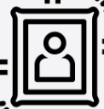 | Art project on text or topic
Music | Composition- Ancient Egypt | Blues | South & West Africa | Holi Festival | Musical Theatre | Looping and remixes
French
Computing

 | Autumn 1 | Autumn 2 | Spring 1 | Spring 2 | Summer 1 | Summer 2
Year 6  Pathways to Write texts | 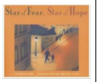  Star of Fear, Star of Hope | 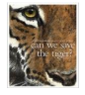  Can we save the tiger? | 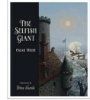  The Selfish Giant | 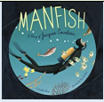  Manfish | 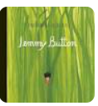  Jemmy Button | 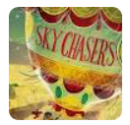  Sky Chasers
Steps 2 Read | 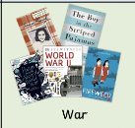 | 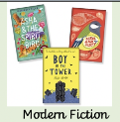 | 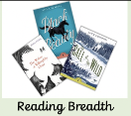  Literary Heritage | 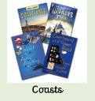 | 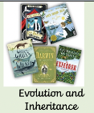 | 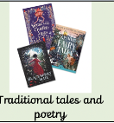
 | History | Geography | History | Geography | History | Geography
History Learning | WW2 and Windrush | Population and Migration  Impact on locality.  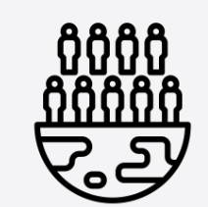 | Crime and Punishment through the last 1000 years.  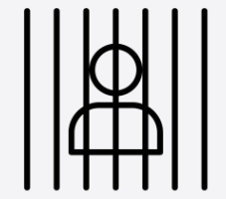 | Coastlines and Oceans  -Marine environments & Coastlines in the North West. | Black History and Slavery  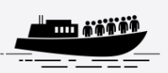 | Independent fieldwork enquiry into a local area issue.  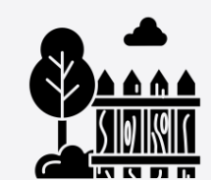
Science | The Circulatory System  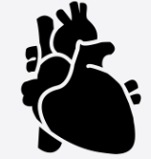 |  | Light | Living things & their habitats  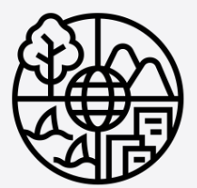 | Evolution | Electricity
RE | Do you believe in something greater? How and Why do Christians worship? | How do Christians show their beliefs in action? | Can you compare Christianity locally and globally? | Sikhism  How do Sikhs worship? | What does it mean to live in a religiously diverse world?
No Outsiders | 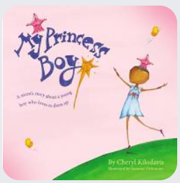  My Princess Boy by Cheryl Kilodavies | 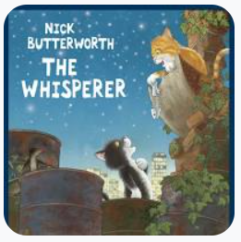  The Whisperer by Nick Butterworth | 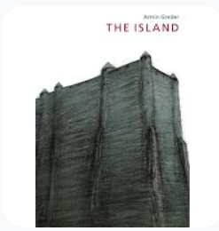  The Island by Armin Greder | 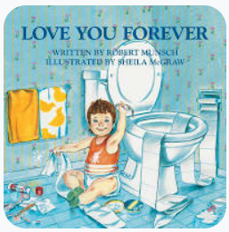  Love you forever by Robert Munsch | 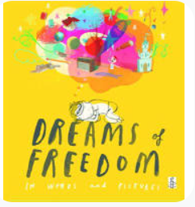  Dreams of Freedom by Amnesty International

D&T | Textiles- Mayan Cushions  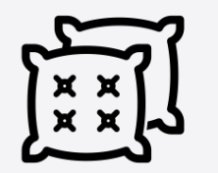 |  | Structures- Playgrounds  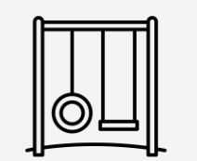 |  | Digital World- Navigating the world  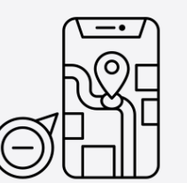
PE | Cross- Country  Tag Rugby & Hockey  Basketball, Circuit training & Indoor Athletics |  | Badminton & Yoga  Tennis & Gymnastics |  | Athletics, Orienteering  Cricket & Rounders
Art | Drawing- Make my voice heard- Street art  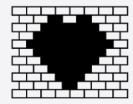 | Art project based on topic or text | Artist study  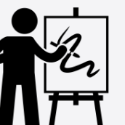 | Art project based on topic or text | Sculpture & 3d- Making memories | Art project based on topic or text
Music | Songs of World War 2 | Film Music | Pop Art | Coasts | Baroque | Leavers song
French
Computing

